20210202 MS2

**3 primer sets**

**2 primer concentrations**

**2 temperatures**

Using MS2 cDNA, PCR was done with 3 primer sets (IDMO00-01, IDMO02-03, IDMO04-05) at 2 different concentrations (.2 uM and .1 uM). These mixes were then run with the same parameters except the annealing temperature. Temp. 1 was 60 0C and Temp. 2 was 63 0C.

For both temperatures, the sample names correspond to the different primer concentrations as follows:

|  |  |
| --- | --- |
| Sample Label: | Primer/Concentration: |
| 1: Sample 1 | IDMO00-01/0.20 uM |
| 2: Sample 2 | IDMO00-01/0.10 uM |
| 3: Sample 3 | IDMO02-03/0.20 uM |
| 4: Sample 4 | IDMO02-03/0.10 uM |
| 5: Sample 5 | IDMO04-05/0.20 uM |
| 6: Sample 6 | IDMO04-05/0.10 uM |
| 7: Sample 7 | Negative Control |

Human errors:

* The capillary holding Sample 5 for Temp. 2 broke before the samples were loaded into the machine so that sample is depicted in the graphs as a flat horizontal line at y=0
* Only one negative control was used for each temperature to see if primer-dimers could be detected/quantified. However, no primer was added to that mix so the data for sample 7 should be discarded.

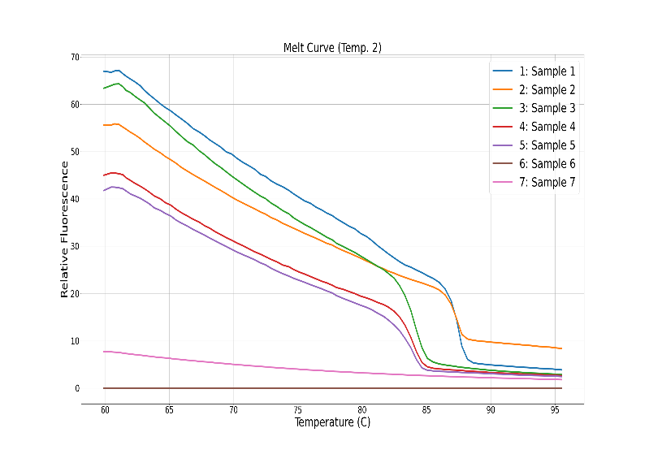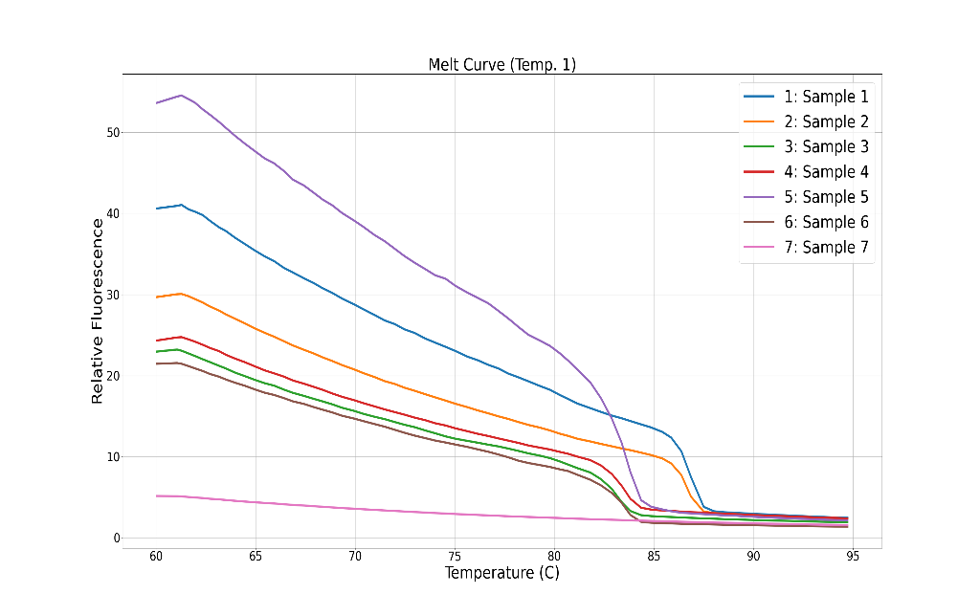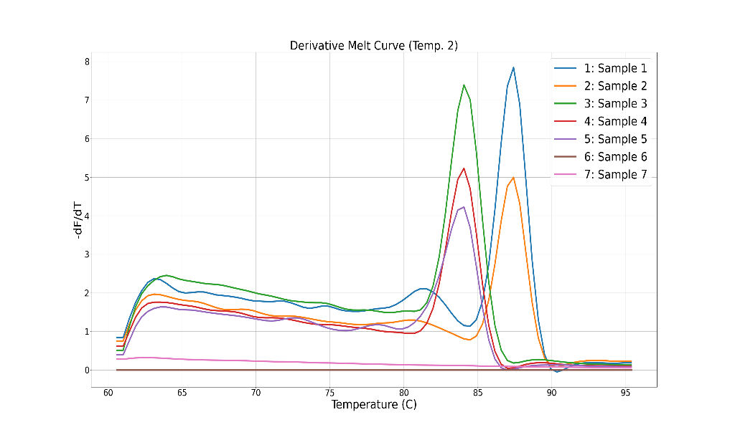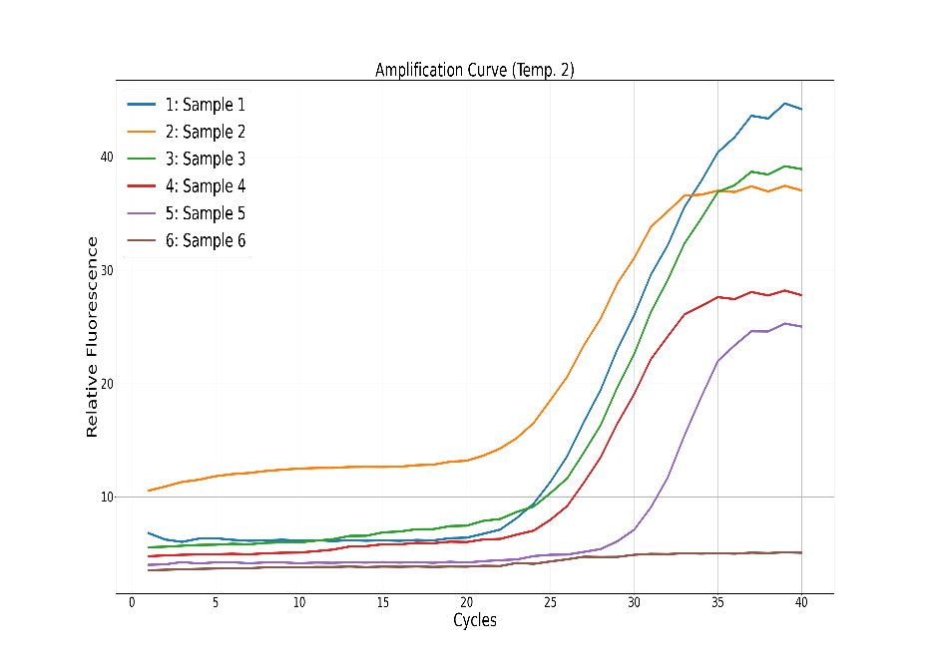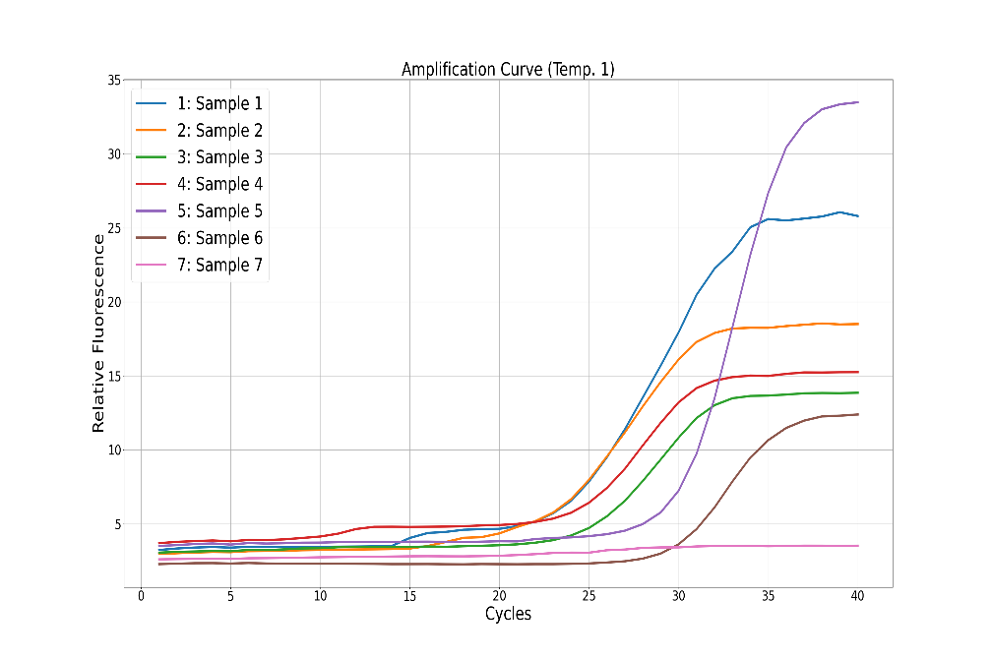

|  |  |
| --- | --- |
| Sample # | Cp Value |
| 1 | 13.48 |
| 2 | 15.18 |
| 3 | 20.61 |
| 4 | 8.46 |
| 5 | 23.80 |
| 6 | 27.66 |

|  |  |
| --- | --- |
| Sample # | Cp Value |
| 1 | 22.37 |
| 2 | 20.42 |
| 3 | 20.97 |
| 4 | 23.19 |
| 5 | X |
| 6 | 28.58 |

|  |  |
| --- | --- |
| Sample # | Tm Value |
| 1 | 87.39 |
| 2 | 87.47 |
| 3 | 83.58 |
| 4 | 83.62 |
| 5 | X |
| 6 | 83.31 |

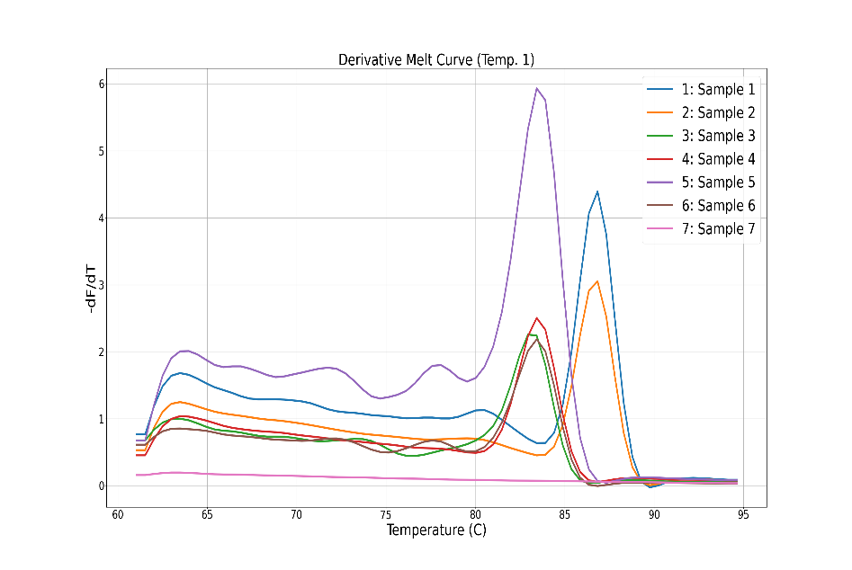

|  |  |
| --- | --- |
| Sample # | Tm Value |
| 1 | 86.58 |
| 2 | 86.91 |
| 3 | 82.73 |
| 4 | 83.20 |
| 5 | 82.89 |
| 6 | 82.97 |

From the Derivative Melt Curves we can see possible formation of primer-dimers, represented as relative maximums at a lower temperature than the absolute maximums. For both temperatures, the lower concentrations seem to be less ideal for the formation of primer-dimers.

The Cp values represent which cycle the template is beginning to amplify so the Cp values can be compared between primer concentrations to determine which concentration would start to amplify earliest.